Hassaan Ali Mehmood (264947)

Muhammad Ahmed Bilal (245987)

User manual

Synchronized File Management Server (Client Server)

**Output of the system**

**Server is Live**

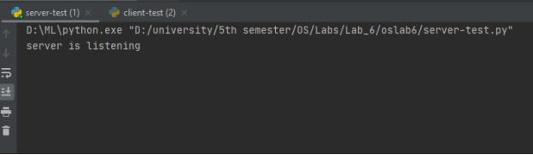

**Client**

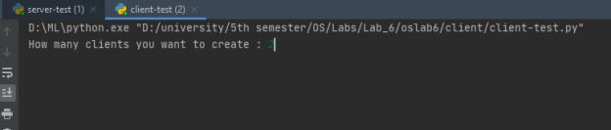

If the server is live you will get the following interface

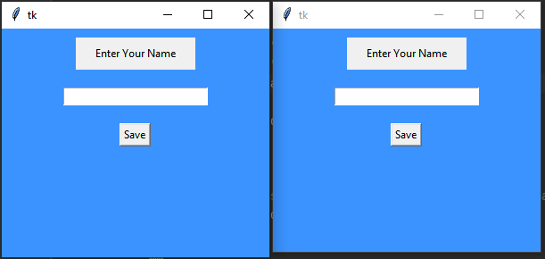

**Otherwise**

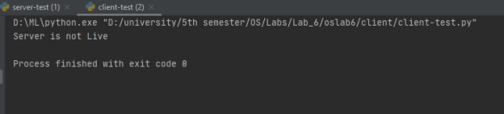

**Username will be visible at the top**

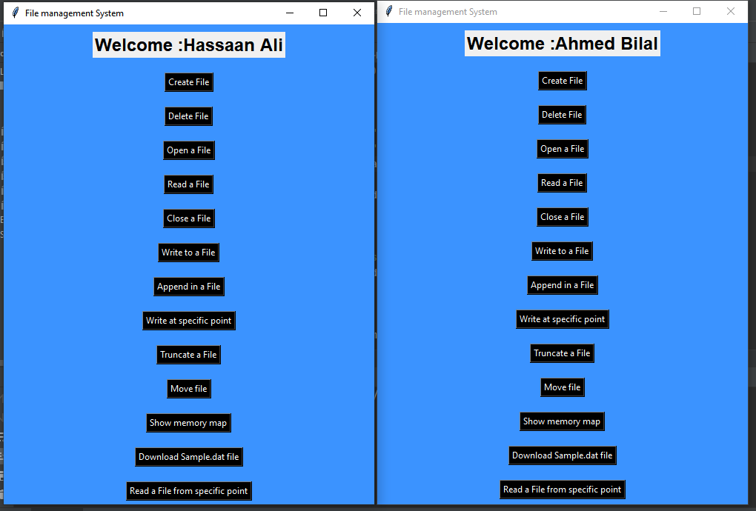

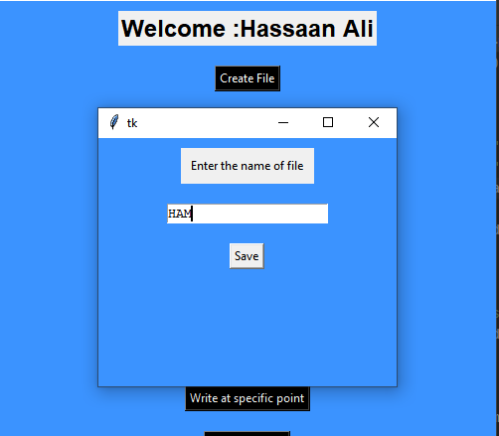

**Suppose we have created a file of name HAM and we have opened this file in a write mode. (Hassaan Ali client). Server will send a successful message to the client.**

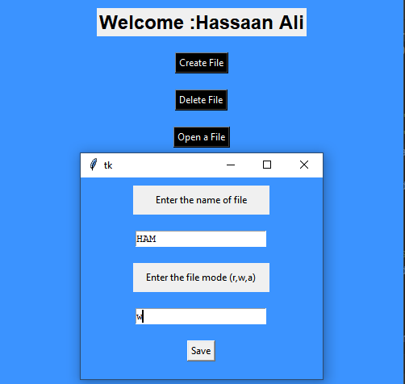

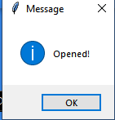

**Now if we try to open this file from another client server will send a warning message.**

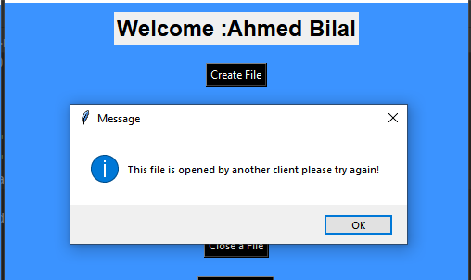

**It means only one client is able to write in a file at a time.**

**Now we will open file in read mode and check whether multiple client are able to read at a time or not.**

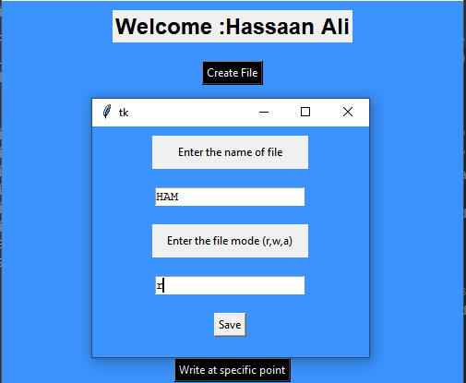

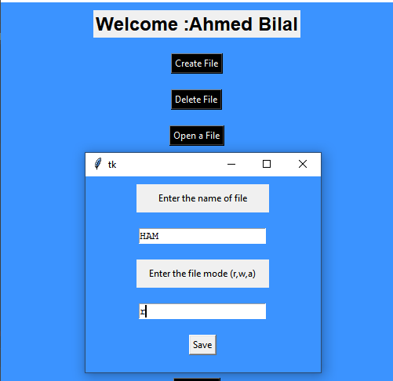

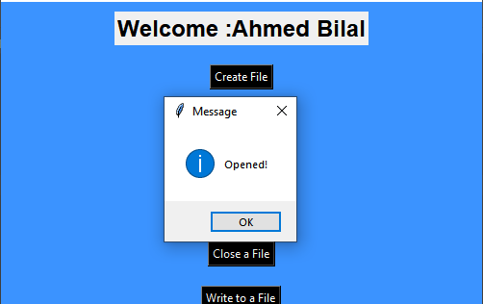

**File is successfully opened. It means multiple client can read the same file at a time.**

**But if another client will try to write into this file, client will receive a warning message.**

**Client Server Functionality**

**Client 1**

**Create**

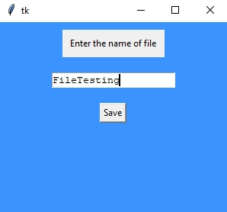

**open**

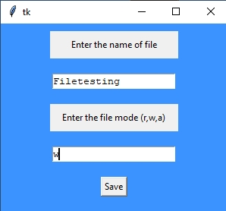

**Write to a file**

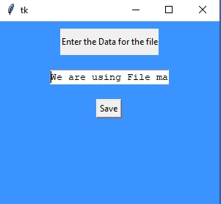

**Server**

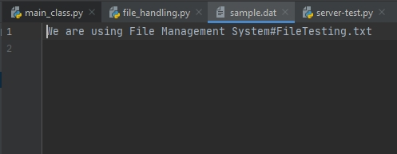

This File Is visible to client 2

Now we will interact as Client 2

**Client 2**

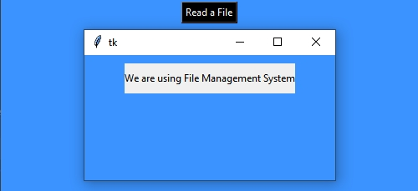

Now we will append in same file as client 2 and see the affect from client 1 view

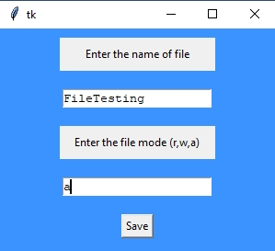

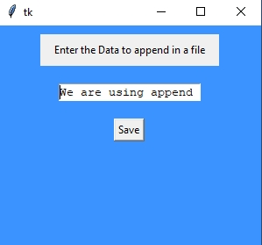

**Server**

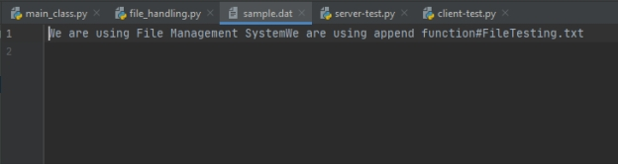

**Client 1**

Now we will interact as Client 1

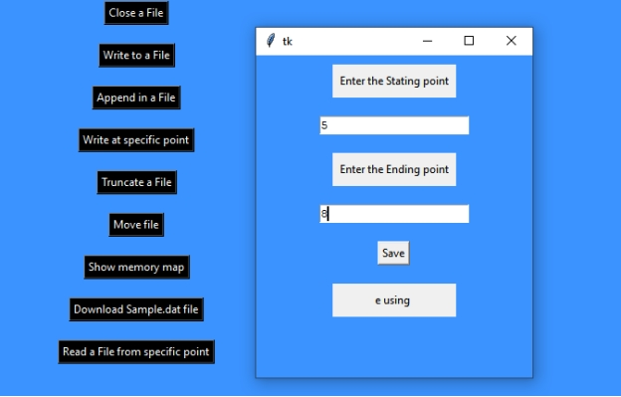

Now we will create another file, perform different operations in Client 1 and download sample.dat file in Client 2

**Client 1**

We have created File2 in client 1

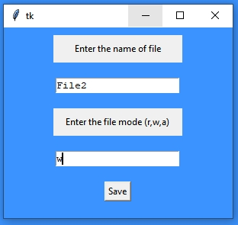

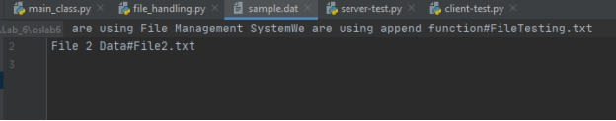

Move within a file function

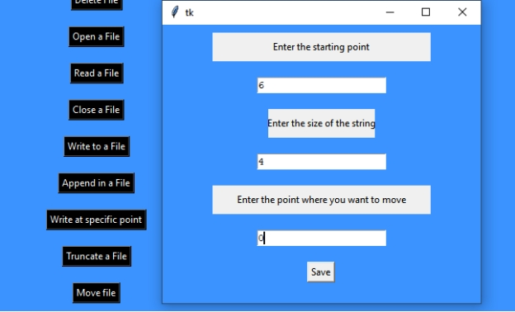

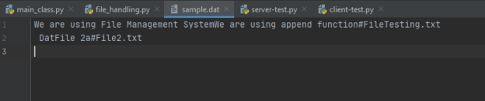

**Client 2**

First, we will see memory map in client 2

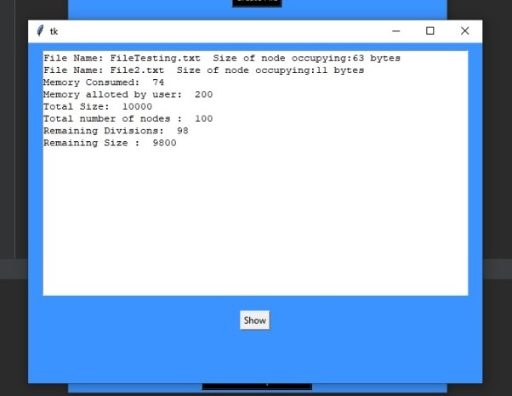

Download sample.dat function in client 2

